**Student Grading Management Sub-System**

For each subject that attended by the student, the lecture will give score to the assessment to each of their assessment. Below figure shows an Example of the assessments for course DBI202.

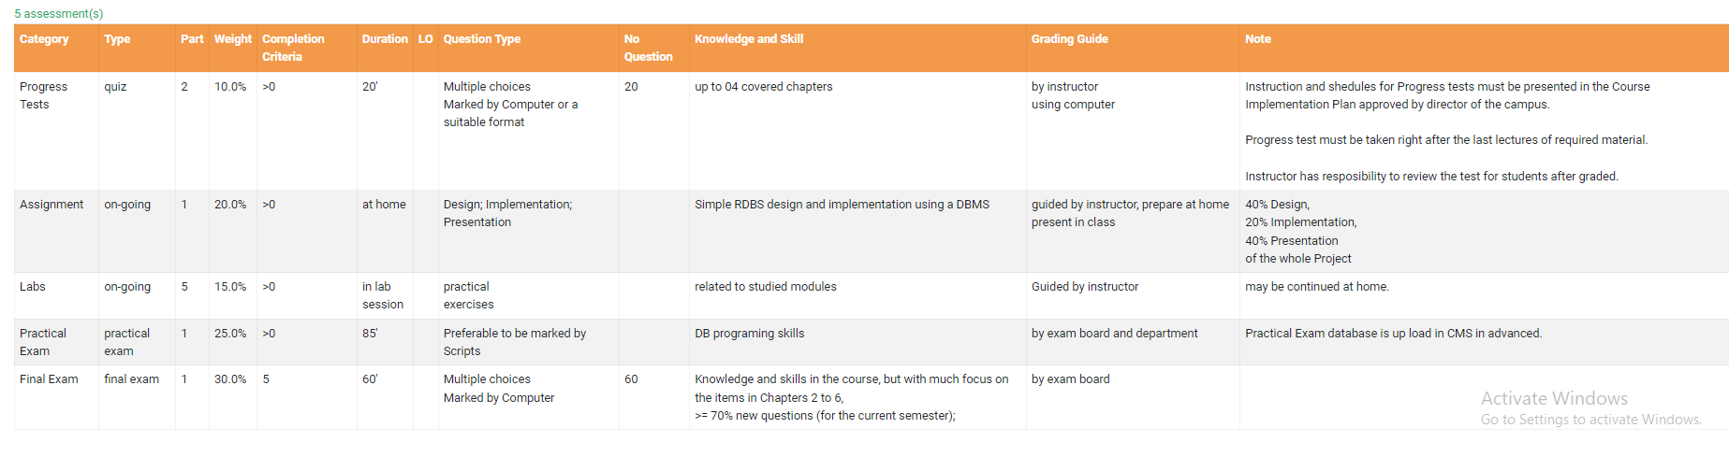

Students can check their results at the end of semester as following example:

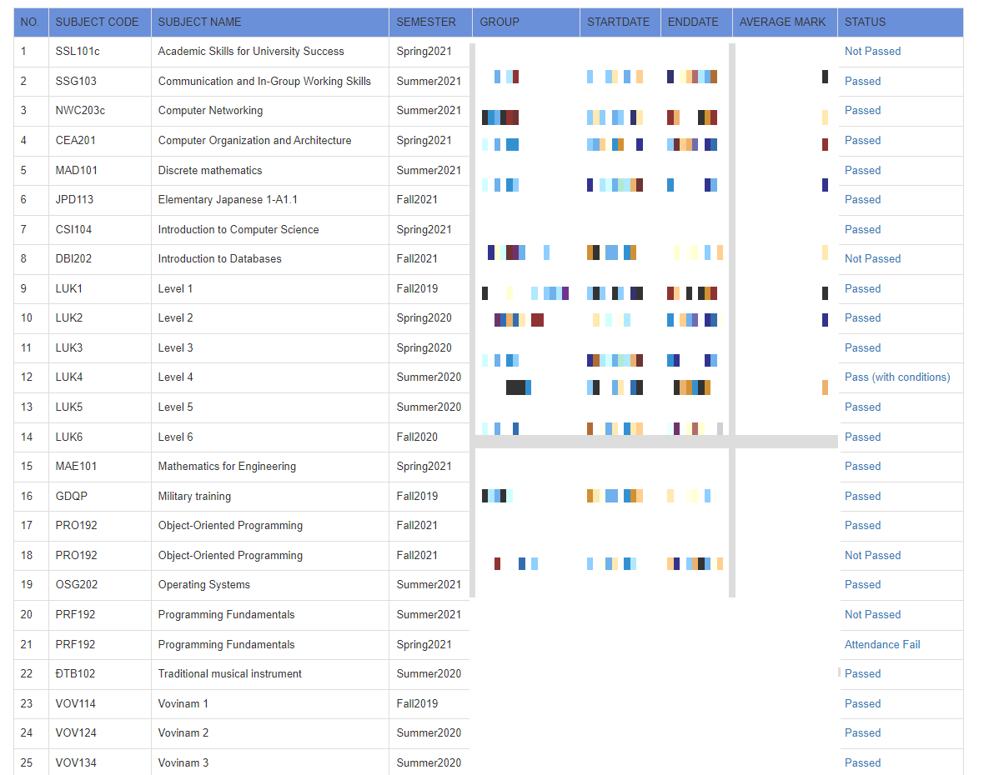

Each Subject code, student can check their detailed result of as below example:

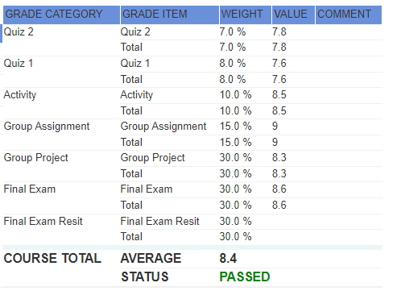

**1. Entites**

**Student**

* Student_ID
* Student_Name
* Contact_Mail
* Sex
* Image
* Address

**Lecture**

* Lecture_ID
* Lecture_Name
* Sex
* Hired_Date
* Subject
* Contact_Mail
* Address

**Course**

* CourseID
* LectureID
* Course_Name
* Session_No
* Student_Materials
* Department
* Semester

**Group**

* Group_ID
* Student_ID
* Course_ID
* Enroll_Date

|  |
| --- |
| **Assessments** |
|  |

* Course_ID
* Category
* Duration
* Question type
* Knowledge and skill
* Grading guide

**Semesters**

* Semester_ID
* Semester_Name
* Start_Time
* End_Time

### Grade

* Category_ID
* Weight
* Score
* Status

### Course_Grade

* Status
* Average Mark
* SubjectCode

### Exam_Grade

* Exam_ID
* Course_ID